ATLAS-LNF

WIRING INSTRUCTION MANUAL
(preliminary version)

MDT assembling machine description
The MDT (Monitor Drift Tube) wiring machine has been designed to assemble up to twenty MDT without manual operations. Operators are only required to load the tube components, control the machine during the wiring and unload the assembled tubes. It is a pneumatic machine (with the exception of the tube loading system) controlled by a PC Labview computer program.

CAUTIONS:TWO PERSONS ARE REQUIRED TO OPERATE THE MACHINE FOR SAFETY REASONS.

Wiring machine check procedure

To get the machine working go through the following steps:

- Turn on the compressor and the vacuum pump switches on the main power panel (see Fig. 1).

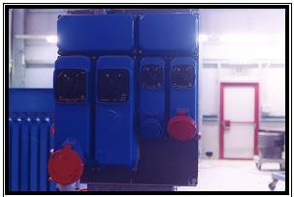
Figure 1 : Main power panel

- Turn on the compressor and the vacuum pump (see Fig 2). Control that the vacuum pump lifetime counter has not exceeded the factory recommended lifetime for maintenance (you can get this value from the vacuum pump maintenance card).
- Wear sterilized white coat, glows and shoes before to get in the clean room.
- Close the high-pressure exhaust valve on the main panel (see fig. 3).
- Open the high-pressure valve on the main panel (see Fig. 3)

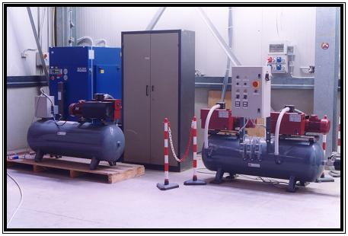
Figure 2 : Compressor and vacuum pump

- Wait until the high-pressure and low-pressure manometers reach the reference values of 220 bar (high-pressure) and 10 bar (low-pressure).
- Control that all the wiring machine traveling parts are in the right start positions.
- Clean the noses and crimping heads (see the “MDT wiring machine maintenance card”).
high-pressure manometer (220bar)
high-pressure valve

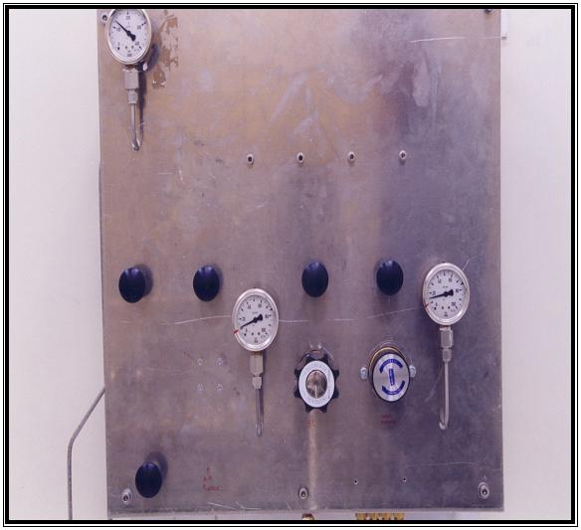
Figure 3 : Main pneumatic control panel
low-pressure manometers (10 bar)
high-pressure exhaust valve

- Check for wire remaining on the machine. Do it carefully for the A side crimping heads and suction tube.
- Start the check program by double clicking the desktop Check icon.
- Run the program clicking on the upper left hand side arrow (see Fig. 4).

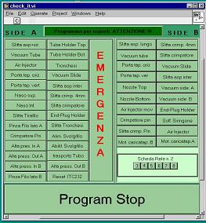
Click this arrow to run the program
Figure 4 : Check program control panel

- As soon as the program starts a window will appear (see Fig. 5); click on Continue.
- Pull the big red button to disable machine emergency stop (see Fig. 7).
- Enable the pneumatic circuit by pushing the red button on the pneumatic control board shown in Fig, 7.
- Do your check on the wiring machine.
- Stop the check program by clicking the Program Stop button on the Check program control panel.

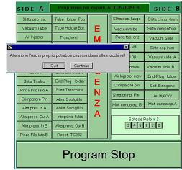
First warning window
Figure 5 : Fist warning of the Check program window control

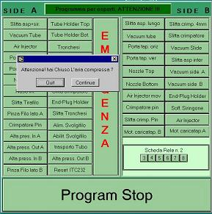
Second warning window
Figure 6 : Second warning window

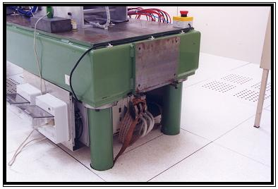
Emergency stop
Pneumatic circuit control panel
Wiring machine
A side
Figure 7: Emergency stop button and pneumatic circuit control board

Wiring machine tube production procedure

- Go through the step 1 to 10 of the check procedure.
- Start the MDT assembling tubes program by double clicking the desktop TuboMatic icon; the control panel shown in Fig 8 will appear.
- Run the program by clicking on the upper left hand side arrow (see Fig. 8) and the start button.
Click this arrow to run the program
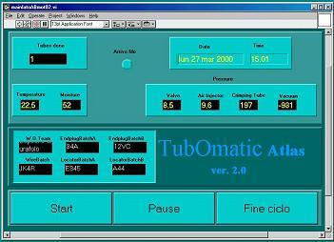
Click on the red button to stop the program
Figure 8: MDT assembling program main panel

- As soon as the program starts, a check window will appear. Control the traveling parts of the machine; if they are in the right start conditions click on the first square.

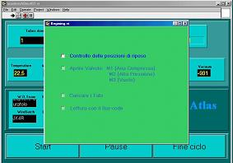
Click here if machine travelling parts are in the right start condition
Click here if manometers pressure values are correct.
Figure 9: TuboMatic initial check panel

- Control the valves and manometers on the main pressure panel (see Fig. 3); if low and high-pressure values are correct, click on the second square of the check window. If the warning window shown in Fig. 10 is shown, enable the pneumatic circuit by pushing the red button on the pneumatic control panel (see Fig. 7), then click on continua.

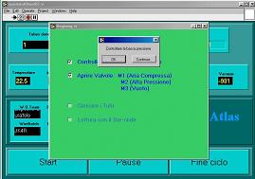
Push the red button on the machine pneumatic control panel; then click on continue
Figure 10: Machine pneumatic circuit disabled warning window

- Load the end-plugs using the end-plug positioning tool (see Fig. 11). Use the LATO A or LATO B button shown in Fig. 12 to rotate the end-plug holder. Click on QUIT when the loading has been completed.

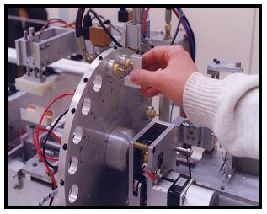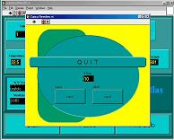
Figure 11:Tubes end-plug loading tool and holder rotation control panel

- Load the tubes on the tube loading system starting from the red market position (Fig. 12).

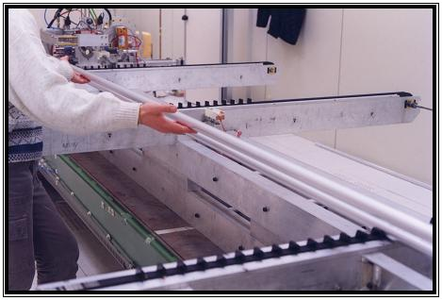
Figure 12: Tubes loading system

- Click on the third square of the panel shown in Fig. 10, then read the bar code on the tubes as shown in Fig. 13 (pay attention to the distance between the bar-code reader and the tube bar-code; the reading operation is critic if you put the reader too close to the tube). The tube codes will be displayed in the window shown in Fig. 14.

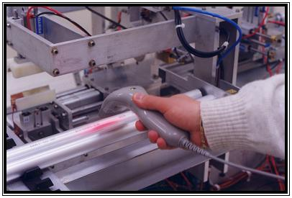

Figure 13: Tube bar code reading procedure

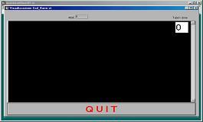
Figure 14: Tube window codes

- Click on the QUIT button (see Fig. 14) and write the module number in the form shown in Fig. 16. Then click on SALVA to store data.
- Control ambient temperature and humidity (see Fig. 16); are they right (temperature should be xx ± x °C, humidity should be x%)? if not, contact the clean room responsible (G. Maccarrone).

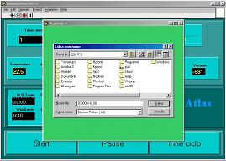
Figure 15: Module number form

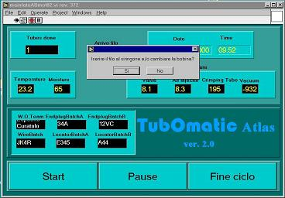
Temperature and humidity values
Wire spool prompt window

Figure 16: Ambient temperature and humidity values

- A prompt window will ask for a new wire spool; click on SI to go to the next step.
- Insert the wire syringe and enable the blowing clicking on the Aria siringone button (see Fig. 17).
- Unroll the spool by hand of two revolutions.
- Disable the blowing clicking again on the Aria siringone button.
- Cut the wire at the far end of syringe. Pay attention: the wire must not be bent.
- Remove the cut wire and throw it in the bin.
- Click on QUIT.
- As soon as you will have clicked on QUIT the MDT tube assembling procedure will start. Control the machine operation until all the tubes will have been assembled.
- When all the tube have been assembled cut the pin extra wires
- Unload assembled tubes and put them on the tube rack
- Go to the step 1 of the MDT assembling procedure.

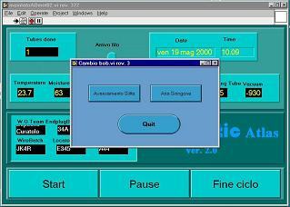
Syringe control panel
Figure 17: Enable syringe panel

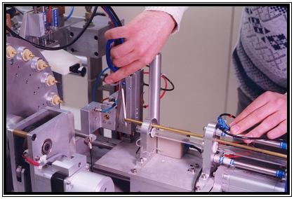
Figure 18: Wire cutting at the syringe far-end

Emergency procedure

In the following some operation procedures are given in case of machine fault. Two emergency stop buttons have been installed on both farthest sides of the machine. Pushing one of them the machine operation is completely stopped.

In case of wiring machine fault:
- Push one of the emergency buttons (pay attention: if the syringe is inserted in the tube you must hold it before pushing the emergency stop button as shown in Fig. 19).

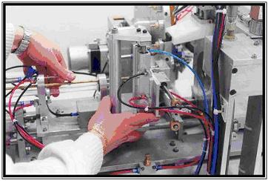
Figure 19: Emergency stop with the syringe inserted inside the tube

- Check for failure and jot down the cause on the wiring machine notebook.
- Cut the wire on the A side of the machine.
- Unload the tube and put it in the damaged tube storing.
- Verify that all the wiring machine components work, otherwise contact the machine responsible.
- Put all the machine movable components in their start positions.
- Load end-plugs and tubes to fill empty spaces on the tube and end-plugs loader.
- Click on the red button of the TuboMatic control panel (see Fig. 8).
- Go back to the Check procedure.

End cycle MDT assembling procedure.

- Exit the TuboMatic program clicking on the control panel red button (see Fig. 8).
- Disable the wiring machine main power pushing one of the two emergency red button.
- Close the high-pressure valve on the main pneumatic control panel.
- Flush the exhaust high-pressure valve.
- Undress the sterilized white coat, glows and shoes before leaving the clean room.
- Turn off the vacuum pump.
- Turn off the compressor.

