BML ASSEMBLY MANUAL

Frascati group

1 - Introduction
The MDT chambers are made of two multilayers of tubes glued to a support structure, named spacer . The spacer is made of three cross plates and two long beams.
The chambers are equipped with an in-plane alignement system, two gas manifolds and the corresponding piping lines, two Faraday cages and four to six platforms for the axial-praxial and projective alignement systems (fig. 1).
In order to achieve the mechanical precision required in the assembly of the chamber, some special tools, containing a high precision jig structure, are used (fig. 2). The jig structure is made of a tube jig – including a set of high precision combs and a vacuum suction system - to hold the tubes in very precise position in a layer , and a spacer jig - including six high precision towers and six sphere holders connected to each side of the three cross plates of the spacer, during the chamber assembly – to ensure the precise positioning of one layer with respect to the others.
The construction of the chamber takes place through various steps: first the spacer is assembled and glued, then the first layer of tubes is assembled on the jig, glued and, at the same time, the cross plates of the spacer are bonded to it. In successive steps the other layers are assembled and glued to the spacer-layers unit. Each of the gluing steps is done in a different day, to let the glue cure before the next step is undertaken.
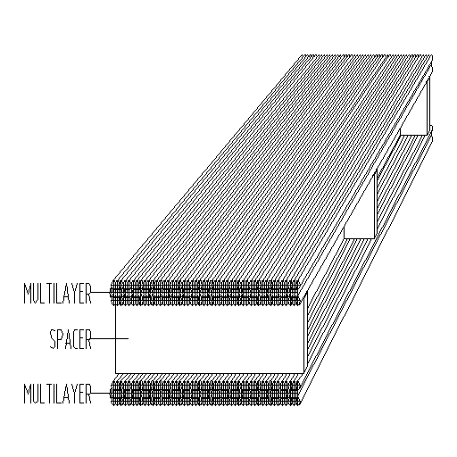

- Fig. 1 -
The assembling is performed in a clean room, with temperature and humidity control. All the materials and components to be used in the assembly step taking place in a certain day have to be stored in the assembly room at latest the evening of the previous day, in order to let them stabilize in temperature.
The 'in-plane' alignment system is mounted on the spacer and is in operation as a monitor during the assembly of the chamber. The additional QA/QC controls are performed during the assembly process by means of a set of monitoring systems installed on the assembly table and on the spacer.
The mounting of the platforms which are used to position the projective and axial alignment sensors is performed during the assembly of the first and last tube layer .
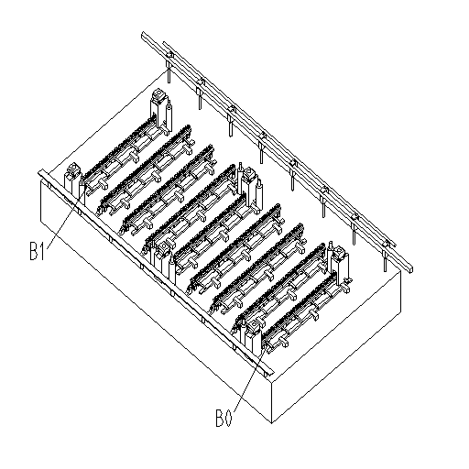

- Fig. 2 -
In order to describe the geometry of the chamber, a system of Cartesian axes x, y, z, will be used (fig. 3) :
x is horizontal, parallel to the tubes
y is vertical
z is horizontal, across the tubes.
where horizontal is defined by the assembly granite table.
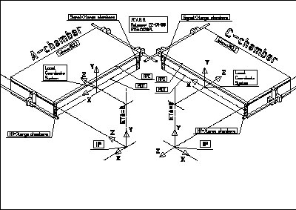

- Fig. 3 -

Several types of the BML chambers are necessary for the spectrometer construction; they differ in tube number per layer and projective platform positions. The list of different types and the number of chambers per type is defined in table 1.

Table 1

 | chamber type side | tube length | n. tubes per layer | projective tower | n. of chambers
 | BML 1 A | 3551.5 | 48 | 3 | 8
 | BML 1 C | 3551.5 | 48 | 3 | 8
 | BML 2 A | 3551.5 | 56 | 1 | 24
 | BML 2 C | 3551.5 | 56 | 1 | 24
 | BML 3 A | 3551.5 | 40 | 2 | 16
 | BML 3 C | 3551.5 | 40 | 2 | 16

The 'Chamber Assembly Team' is made of 3 people: two of them are responsible for the mechanical procedures; the third one is responsible for the computer controlled operations. They will be designated in the following as Operator 1 (O1), Operator 2 (O2), Operator 3 (O3). O3 is also responsible for the book-keeping of the operations accomplished.
They have to operate inside the clean room using proper protections against dust, and gloves to manipulate tubes and other chamber components.
The next section (Chamber Assembly Procedure section) decribes on a step-by-step basis the exact sequence of operations to be performed. Complex procedures are described in detail in the Appendices. Actual pictures of the main components (in italics in the text) can be found in the Glossary section.
The construction process is controlled by an Online Monitoring System (OLMS) which takes care of steering the actions of the construction team according to the Chamber Assembly Procedure , monitoring the environmental parameters , operating QC devices ; it issues warning messages and logs all relevant information in the Muon Construction Data Base (MCDB).
The Appendices and the Glossary are available in the online help of the OLMS .

2- Chamber Assembly Procedure

Step | Description | Detail reference
1 | Preparation
1.01 | General cleaning of the clean room | Appendix 1
1.02 | Log into the OLMS | OLMS manual
1.03 | Select chamber type | Table 1
1.04 | Inizialize hardware.  Environmental sensors , alignement sensors , services. | OLMS manual
1.05 | Start automatic environment logging. | OLMS manual
2 | Assembly of the Spacer | Appendix 2

3 | Assembly of Layer 1,  chamber side A
3.01 | Sag compensation off.  Remove the sag compensation bar from the long beams.  Dismount the squares from the cross plates and long beams and remove the squares from the assembly table.
3.02 | Mount auxiliary plates on the spacer
3.03 | Crane enabled.  Lift spacer using crane.  (about 1m. above the assembly table)
3.04 | Calibration (= zeroing) of the monitoring systems:
 | a) Rasnik cross plate sag compensation system, | Appendix 3
 | b) Rasnik sphere monitoring system, | Appendix 4
 | c) Rasnik in plane system. | Appendix 5
3.05 | Positioning of the tubes on the combs . Vacuum system on..  Tube bar code reading. | Appendix 6
3.06 | Test for vacuum system leakage. | Appendix 7
3.07 | Measurement of layer planarity. | Appendix 8
3.08 | Bonding of the tubes (first layer). | Appendix 9
3.09 | Distribution of the glue for bonding the tubes to the cross plates. | Appendix 10
3.10 | Positioning of the spacer on the precision towers. | Appendix 12
3.11 | Crane disabled.
3.12 | Sag compensation system switched on (force value set for 0 layers ). Measurements with the assembly monitoring systems: | Appendix 13
 | a) cross plate sag compensation,
 | b) sphere monitoring,
 | c) in plane.
3.13 | Data acquisition for all the monitoring systems during the glue curing time. | Appendix 14

4 | Assembly of Layer 1,  Chamber side B
4.01 | Check of the monitoring systems.  Temperature , humidity , pressure values entered in database.
4.02 | Sag compensation off.
4.03 | Vacuum off.
4.04 | Crane enabled.
4.05 | Lift chamber using crane (about 1m. above assembly table) .
4.06 | Rotation of the chamber by 180 degrees around Z axis. | Appendix 15
4.07 | Positioning of the tubes on the combs . Vacuum system on.  Tube bar code reading. | Appendix 6
4.08 | Test for vacuum system leakage. | Appendix 7
4.09 | Measurement of layer planarity | Appendix 8
4.10 | Bonding of the tubes (first layer). | Appendix 9
4.11 | Distribution of the glue for bonding the tubes to the spacer. | Appendix 10
4.12 | Positioning of the spacer on the precision towers. | Appendix 12
4.13 | Crane disabled.
4.14 | Sag compensation system switched on (force value set for 1 layer ). Measurements with the Rasnik assembly monitoring systems: | Appendix 13
 | a) cross plate sag compensation,
 | b) sphere monitoring,
 | c) in plane.
4.15 | Data acquisition for all the monitoring systems during glue curing time. | Appendix 14

5 | Assembly of Layer 2,  chamber side B
5.01 | Check of the monitoring systems.  Temperature , humidity , pressure values entered in database.
5.02 | Sag compensation off
5.03 | Vacuum off
5.04 | Crane enabled
5.05 | Lift chamber using crane (about 1m above the assembly table).
5.06 | The interfaces type 1 are dismounted and the interfaces type 2 are mounted on all the precision towers.
5.07 | Positioning of the tubes on the combs. Vacuum system on.  Tube bar code reading. | Appendix 6
5.08 | Test for vacuum system leakage. | Appendix 7
5.09 | Measurement of layer planarity | Appendix 8
5.10 | Positioning of Tape to correct the gap Layer 1 / Layer 2 (50 µ) | Appendix 16
5.11 | Bonding of the tubes (second layer). | Appendix 11
5.12 | Positioning of the chamber on the precision towers | Appendix 12
5.13 | Crane disabled
5.14 | Sag compensation system switched on (force value set for 2 layers). Measurements with the assembly monitoring systems: | Appendix 13
 | a) cross plate sag compensation,
 | b) sphere monitoring,
 | c) in plane.
5.16 | Data acquisition for all the monitoring systems during the glue curing time | Appendix 14

6 | Assembly of Layer 2,  chamber side A
6.01 | Check of the monitoring systems.  Temperature , humidity , pressure values entered in database.
6.02 | Sag compensation off
6.03 | Vacuum off
6.04 | Crane enabled
6.05 | Lift chamber using crane (about 1m above the assembly table).
6.06 | Rotation of the chamber by 180 degrees around Z axis | Appendix 15
6.07 | Positioning of the tubes on the combs. Vacuum system on.  Tube bar code reading. | Appendix 6
6.08 | Test for vacuum leakage | Appendix 7
6.09 | Measurement of layer planarity | Appendix 8
6.10 | Positioning of Tape to correct the gap Layer 1 / Layer 2 (50 µ) | Appendix 16
6.11 | Bonding of the tubes (second layer). | Appendix 11
6.12 | Positioning of the chamber on the precision towers | Appendix 12
6.13 | Crane disabled
6.14 | Sag compensation system switched on (force value set for 3 layers). Measurements with the assembly monitoring systems: | Appendix 13
 | a) cross plate sag compensation,
 | b) sphere monitoring,
 | c) in plane.
6.16 | Data acquisition for all the monitoring systems during the glue curing time | Appendix 14

7 | Assembly of Layer 3,  chamber side A
7.01 | Check of the monitoring systems.  Temperature , humidity , pressure values entered in database.
7.02 | Sag compensation off
7.03 | Vacuum off
7.04 | Crane enabled
7.05 | Lift chamber using crane (about 1m above the assembly table).
7.06 | Dismount the interfaces type 2 and mount the interfaces type 3 on all the precision towers
7.07 | Positioning of the tubes on the combs. Vacuum system on.  Tube bar code reading. | Appendix 6
7.08 | Test for vacuum system leakage. | Appendix 7
7.09 | Measurement of layer planarity | Appendix 8
7.10 | Bonding of the tubes (third layer) | Appendix 11
7.11 | Positioning of the chamber on the precision towers | Appendix 12
7.12 | Crane disabled
7.13 | Sag compensation system switched on (force value set for 4 layers). Measurements with the assembly monitoring systems: | Appendix 13
 | a) cross plate sag compensation,
 | b) sphere monitoring,
 | c) in plane.
7.15 | Data acquisition for all the monitoring systems during the glue curing time | Appendix 14

8 | Assembly of Layer 3,  Chamber side B
8.01 | Check of the monitoring systems.  Temperature, humidity, pressure values entered in database.
8.02 | Sag compensation off.
8.03 | Vacuum off
8.04 | Crane enabled
8.05 | Lift chamber using crane (about 1m above assembly table)
8.06 | Rotation of chamber by 180 degrees around Z axis | Appendix 15
8.07 | Positioning of the tubes on the combs . Vacuum system on.  Tube bar code reading. | Appendix 6
8.08 | Test for vacuum system leakage | Appendix 7
8.09 | Measurement of layer planarity | Appendix 8
8.10 | Bonding of the tubes (third layer). | Appendix 11
8.11 | Positioning of the chamber on the precision towers | Appendix 12
8.12 | Crane disabled
8.13 | Sag compensation system switched on (force value set for 5 layers). Measurements with the assembly monitoring systems: | Appendix 13
 | a) cross plate sag compensation,
 | b) sphere monitoring,
 | c) in plane.
8.15 | Data acquisition for all the monitoring systems during the glue curing time | Appendix 14

9 | Final operations
 | The final operations on the assembled chamber are performed in the same day in which the assembly of the next chamber of the same type starts.
9.01 | Sag compensation off
9.02 | Vacuum off
9.03 | Lift chamber using crane
9.04 | Rotate the chamber in vertical (rotation around the x-axis). | First part of  Appendix 15
9.05 | Put the chamber on the carriage
9.06 | Push the chamber/carriage outside the assembly room

Appendices

(Definition and detailed description of the operations to be accomplished during the assembly of the chamber)

Appendix 2 -
Assembly of the spacer

The 6 sphere holders, with the 6 spheres inside, are mounted on each side of the 3 cross plates.
The appropriate support blocks are fixed at the ends of the long beams.
The interfaces type 1 are placed in the six precision towers.
The spheres connected to the central cross plate are positioned in the sphere housings and the cross plate is fixed in vertical position.
The long beams are inserted into the cross plate holes; each long beam is temporarily supported at two positions.
The outer cross plates are mounted at the two ends of the long beams, positioning their spheres in the respective sphere housings.
The sag adjustment housing is inserted in the middle of the cross plate.
The in plane and sphere monitor Rasnik systems are switched on to check that the images are sharp and analyzable.
The long beams are glued in the cross plates.
Minimum glue curing time = 10h

Appendix 3 -
Calibration of the Rasnik sag compensation system

The calibration (zeroing) of the Rasnik sag compensation system is performed after the spacer is glued, at the beginning of the chamber assembly. The procedure is the following:
The spacer is positioned on the jig by means of the spheres. A measurement with the Rasnik systems is taken , then the spacer is rotated by 180 degrees around the z-axis , following the procedure described in Appendix 15 , and the measurement with the Rasnik systems is repeated.
The zero value for the sag compensation system is obtained by averaging, for each coordinate, the values obtained in the two measurements.
The value has to be entered into the Data Base.

Appendix 4 -
Calibration of the Rasnik sphere monitoring system

Appendix 5 -
Calibration of the Rasnik in-plane monitoring system

Appendix 6 -
Positioning of the tubes on the combs

One tube at the time is taken by O1 and O2 from the tube storage to be positioned on the combs.
Before positioning the tubes on the combs , the combs are inspected for checking the absence of dust or comb defects. Every tube is visually inspected to check its cleanliness and integrity (no evident straightness deviation and no scratches or marks have to be present on the tube; if so, the tube has to be set aside and not used in the chamber).
The bar code on the tube is read and entered into the database.
The tool for tube clocking is mounted on the end plug (fig. 4).
O1 and O2 position the tubes on the combs, starting from the reference side.
After the completion of the tube layer on the combs, the vacuum system is switched on, following the sequence of operations as described in fig. 5.

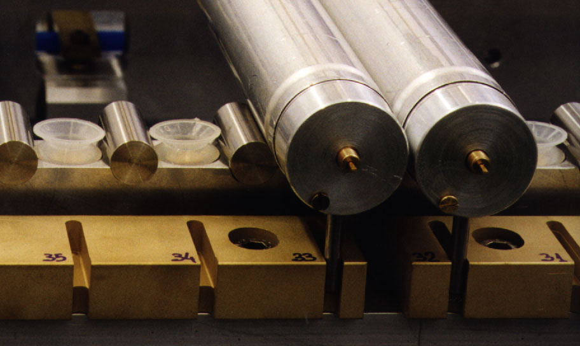

- Fig. 4 -

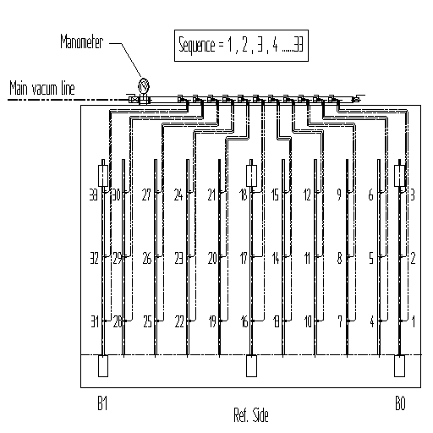

- Fig. 5 -

Appendix 7 -
Test of the vacuum system

For every comb the corresponding vacuum line is checked by means of a manometer measuring the under pressure in the vacuum system. The under pressure value must be 960 mbar, corresponding to a sucking force of 0.6 kg acting through every sucker .

Appendix 8 -
Measurement of the layer planarity

The highest point of the endplug reference surface on the two external combs of the jigging for all the tubes of the layer is measured. The measurement is done by means of a Mitutoyo mechanical feeler with precision level of the order of few microns. The Mitutoyo, with digital output, connected to a computer, is mounted on a precise rail along the z-direction; the granite table surface is used as y reference.
The procedure of the measurement is the following:
A ‘zero’ measurement on the first tube of the layer is taken.
The Mitutoyo is moved slowly along the rail and the data are recorded.
At the end the measurement of the ‘zero’ is repeated for verification..
The data are analyzed and the highest values of the y coordinate of the reference surface for all the endplugs are compared. If one tube is ‘higher’ with respect to the others by more than 30 microns, is repositioned and eventually is changed.

- Fig. 7 -

Appendix 9 -
Bonding of the first layer of tubes (of each multilayer)

The wheel for gluing the first layer of tubes is mounted on the glue machine (fig. 8).
The glue machine is positioned in the starting position at one end of the non-reference side and it is filled with Araldit 2011.
The speed of the machine has to be set at the reference value so that the total distributing time does not exceed 20-30 min.
The machine is started and the glue is distributed on the tubes. The Operators check visually the uniform and correct distribution of the glue. The glue distribution has to be stopped 2 mm before the tube – endplug crimp region at the tube ends.

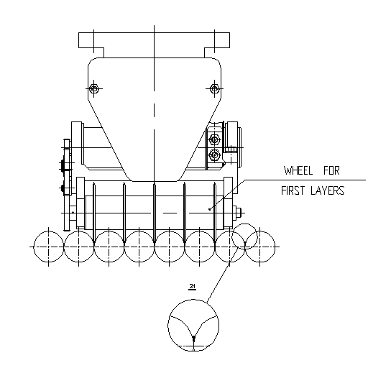

- Fig. 8 -

Appendix 10 -
Bonding of the tubes to the cross plates

The glue, type 3M490, is manually distributed , along each tube , on the previously marked locations (fig. 9) where the tubes have to be glued to the cross plates .
The dimensions of the stripes of glue deposited on each tube have to be 3 mm in diameter and 60 mm in length , approximately. The standard ‘static mixer’ , provided by Ciba , can be conveniently used for this operation.
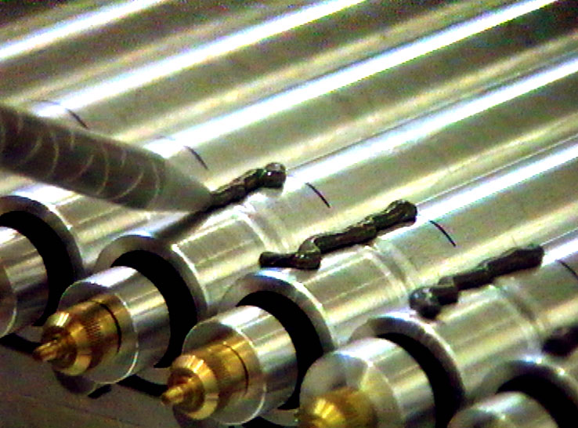

- Fig. 9 -

Appendix 11 –
Bonding of tubes (of the second and third layers of each multilayer)

The wheel for gluing the second and third layer of tubes is mounted on the glue machine (fig. 10).
The glue machine is positioned in the starting position at one end of the non-reference side and it is filled with Araldit 2011.
The switches on the guide of the machine have to be set such that the glue lines are discontinued in the locations of the tubes where the separator tape has to be placed.
The machine is started and the glue is distributed on the tubes. The Operators check visually the uniform and correct distribution of the glue. The glue distribution has to be stopped 2 mm before the tube – endplug crimp region at the tube ends.

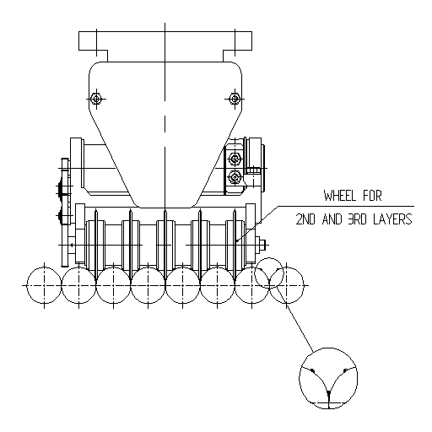

- Fig. 10 -

Appendix 12 –

Positioning of the spacer/chamber on the precision towers

O3 starts lowering the crane (medium speed). When the spacer/chamber is approximately 10 cm above the towers, the flanges are disengaged and the spacer/chamber is lowered at very low speed until the spheres arrive at rest into the respective sphere housings.
It is recommended that O1 and O2 keep the spacer slightly inclined so that the spheres on the reference side are slightly lower than the spheres on the other side.
At one end of the reference side, O1 guides the sphere, that has to go into the fix sphere-housing B_0
(fig. 2) , controlling the movement of the sphere up to the final position, at rest.
O2 guides the sphere that has to go into the sphere-housing B_1 (fig. 2), at the other end of the reference side, up to the sphere final position, at rest.
The other 4 spheres go in position by themselves.
O1 and O2, at the two sides of the chamber,
a) check that the end-blocks of the crane are disengaged from the fork of the crane,
b) tighten the screws on the flanges,
c) dismount the auxiliary plates releasing the screws (fig. 11).
O3 lifts the crane approximately 1m above the granite table.

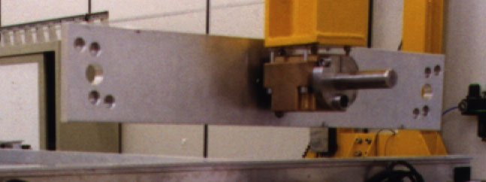

- Fig. 11 -

Appendix 13 -

Measurements with the assembly monitoring systems

The Operators put the loads over the cradle on top of the sphere-holders (fig. 12).

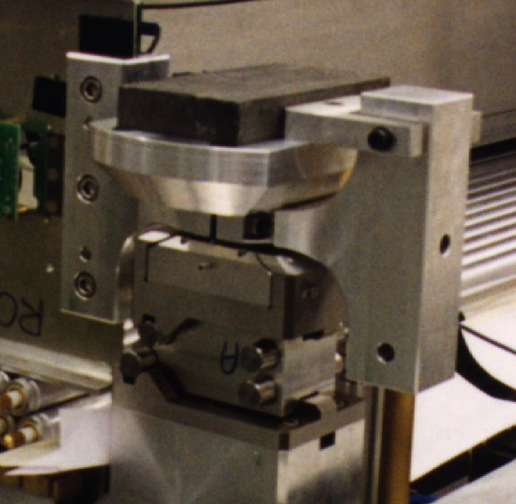

- Fig. 12 -
The compensating force is set at 90% of the nominal value listed in table 2 .
Table 2
Layer | Outer cross plate  (kg)  BML 1 A/C BML 2 A/C BML 3 A/C |  | Central cross plate  (kg)  BML 1 A/C BML 2 A/C BML 3 A/C
0 |  | 16,2 |  | 12.0
1 |  | 19,8 |  | 14.6
2 |  | 23,4 |  | 17.2
3 |  | 27,0 |  | 19.8
4 |  | 30.6 |  | 22.4
5 |  | 34.2 |  | 25.0

The Rasnik systems for
cross plate sag compensation monitoring
sphere monitoring
in plane monitoring
are switched on.
The values read by the monitoring systems have to be equal to the ‘zero’ values (see3.2) within 10 μm .
If the zero values are not reproduced, the cross plate sag compensating force must be varied so that the zero values are reproduced within 10 μm.

3.13 Data acquisition during glue curing time
During the glue curing time data are taken every 30 min.(and stored in the local Data Base) for the Rasnik systems :
a) cross plate sag compensation,
b) sphere monitoring,
c) in plane.

3.14 Rotation (of the spacer or of the chamber) by 180 degrees around the z-axis

The operation is accomplished by means of the lifting/rotating system. O3 operates the crane, raising very slowly the spacer/chamber . O1 and O2 hold the spacer/chamber preventing it from oscillating.
When the spacer/chamber is raised by about 10 cm, the flanges on the two sides of the spacer are fixed by tightening the screws A (fig. 13)

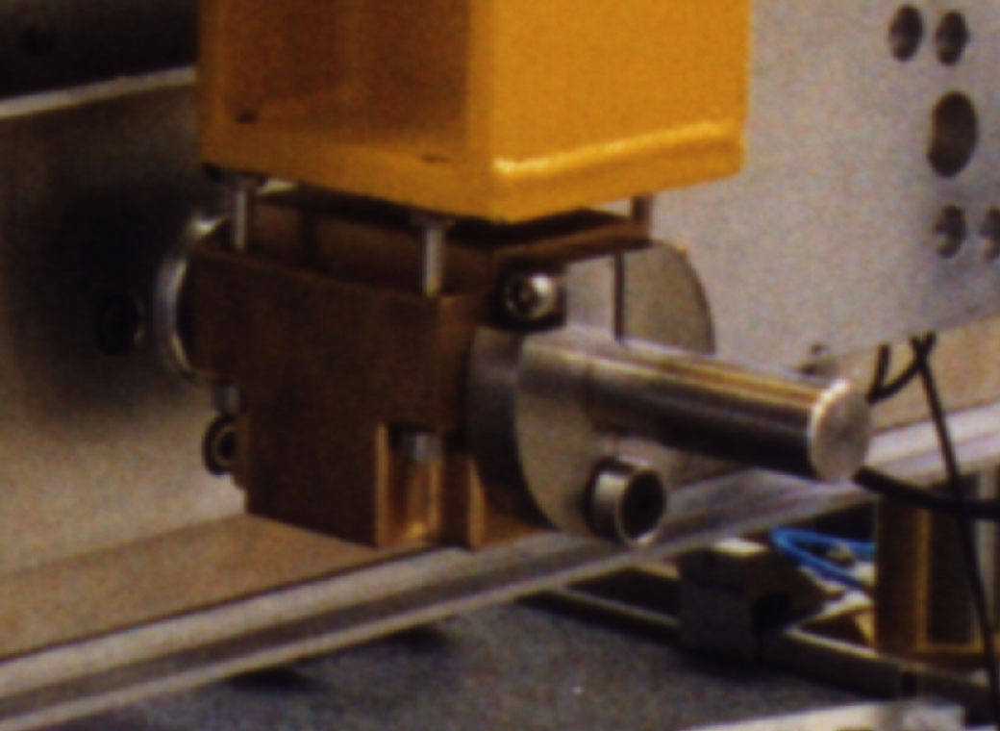

- Fig. 13 -

The spacer/chamber is further raised (medium speed) up to a height slightly larger than half width of the spacer/chamber. The crane is stopped. O1 and O2 release the screw A (fig. 14) and rotate the spacer/chamber around the x axis.

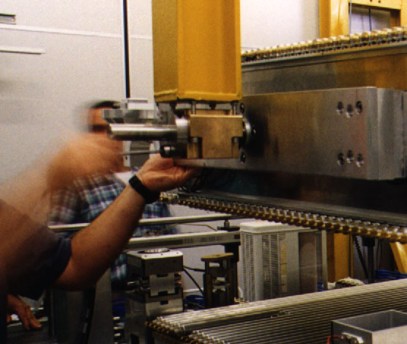

- Fig. 14 -

After this rotation the spacer/chamber is up side down . Then O1 and O2, holding the spacer at the outer cross plates, make it to rotate slowly around the vertical direction. After this rotation the RO and the HV side of the chambers are interchanged (fig. 15);

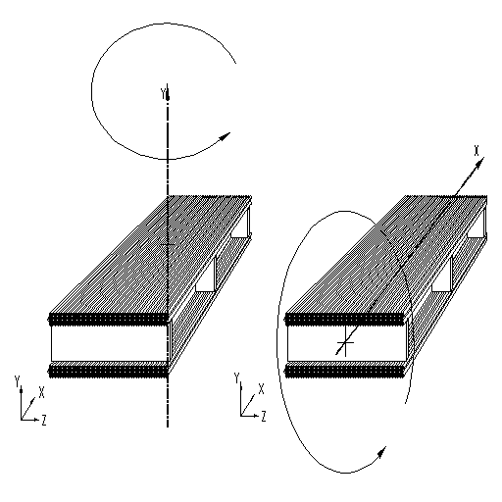

- Fig. 15 -

O1 and O2 tighten the screws A fixing the flanges and the spacer/chamber is blocked.
O3 starts lowering the crane (medium speed). When the spacer/chamber is approximately 10 cm above the towers, the flanges are disengaged and the spacer/chamber is lowered at very low speed until the spheres arrive at rest into the respective sphere-housings.
It is recommended that O1 and O2 keep the spacer/chamber slightly inclined so that the spheres on the reference side are slightly lower than the spheres on the other side. O1 guides the sphere, at one end of the reference side that has to go into the fix sphere-housing B_ 0 (fig. 2), controlling the movement of the sphere up to the final position, at rest. O2 guides the sphere, that has to go into the sphere-housing B_1 (fig. 2 ), at the other end of the reference side, up to the final position, at rest. The other 4 spheres go in position by themselves.

Appendix 16 -

Positioning of tape to correct the gap Layer1/Layer2

After the tubes belonging to the second layer of each multilayer have been positioned on the combs and the vacuum sucking system is activated , a strip of adhesive tape, 60 μm thick, has to be put on the tubes ; the tape has to be positioned in two lines , transversal to the tube direction, at approximately half distance between the central precision tower and each one of the two outer precision towers. Then the tape has to be cut between every two adjacent tubes .

