GLOSSARY

Spacer
Cross Plates
Long Beams
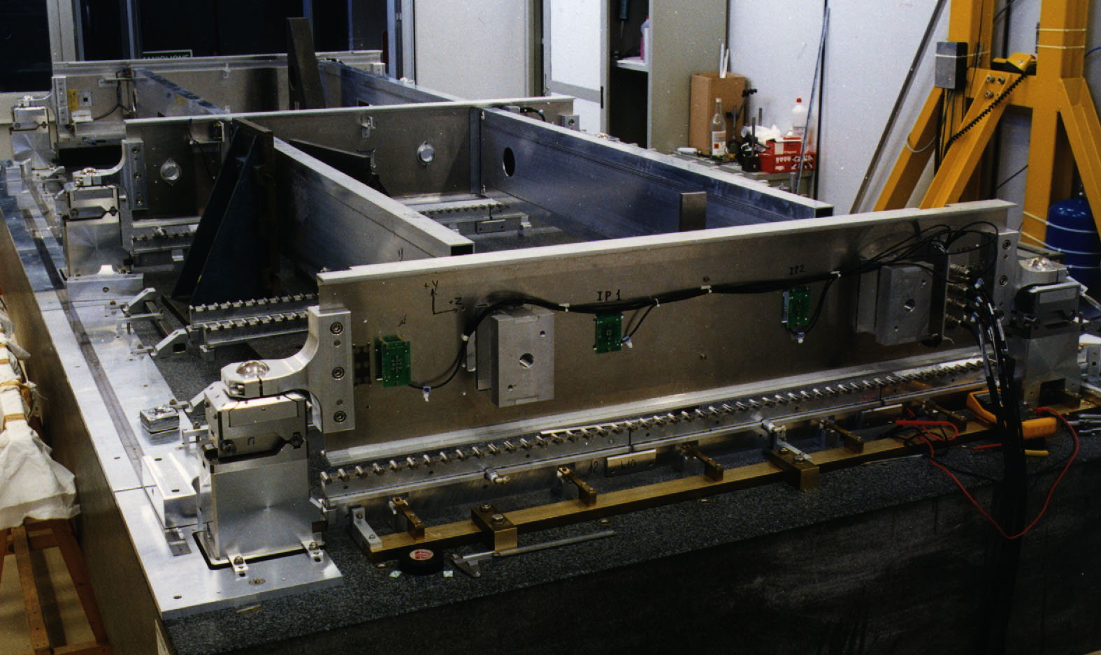
Spacer Assembly tooling

Set Squares
Sag compensation mechanism
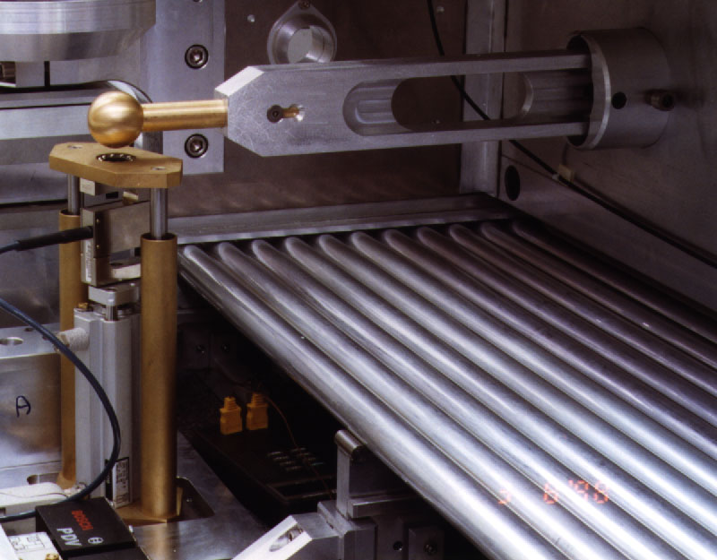
Force trasferring bar
sensor
Pneumatic piston

pistone

pi

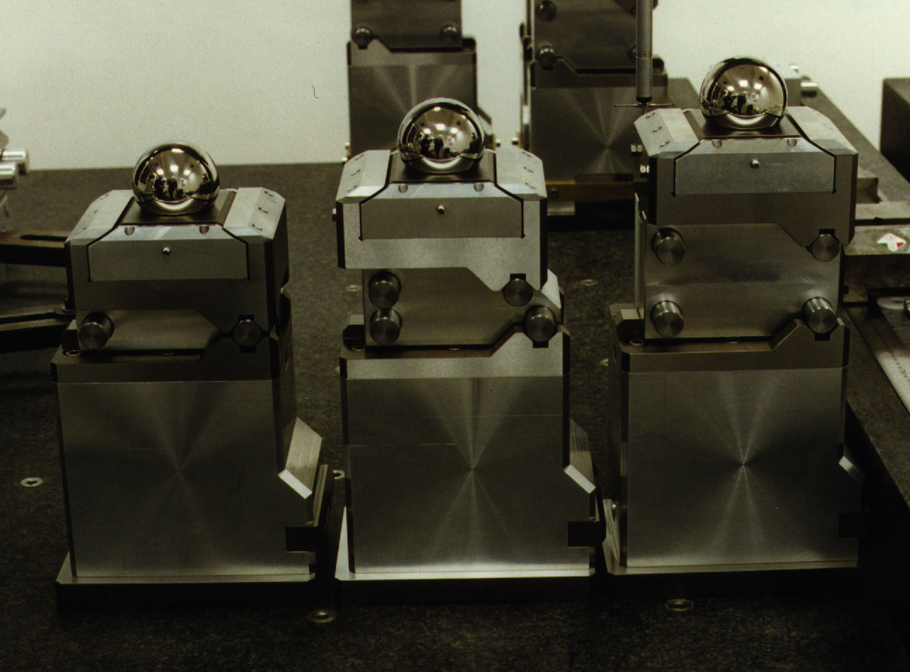
Precision Towers
Interfaces 1, 2, 3
Sphere Housing

Sphere location
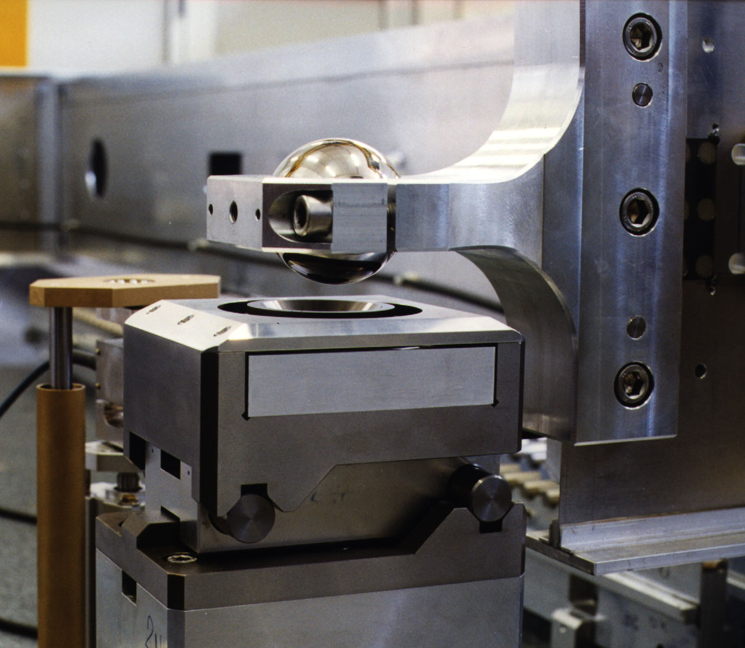
sphere holder
Sphere housing
Load

Load ~ 12 kg
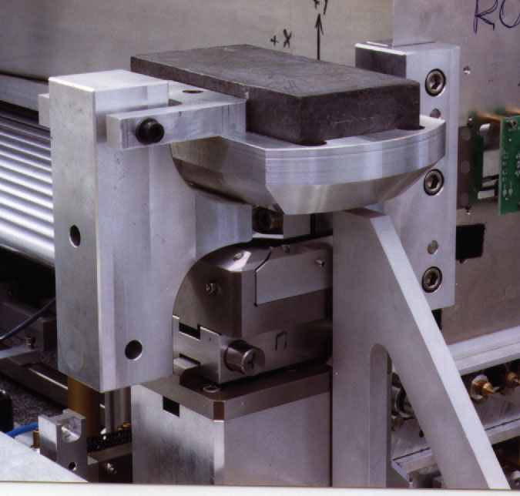

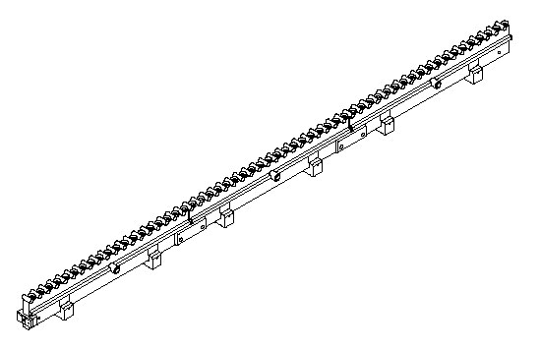
Comb

comb or combline
sucker
vacuum line
Glue Dispenser

wheel
reservoir

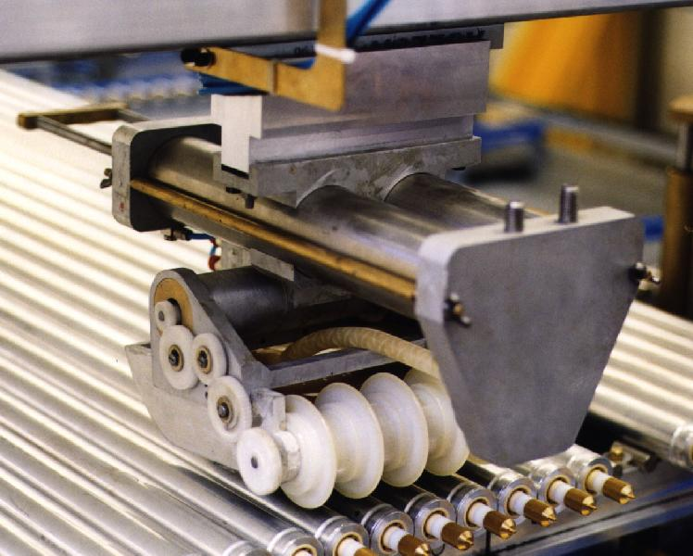
wheel
reservoir
Fig 8

Crane
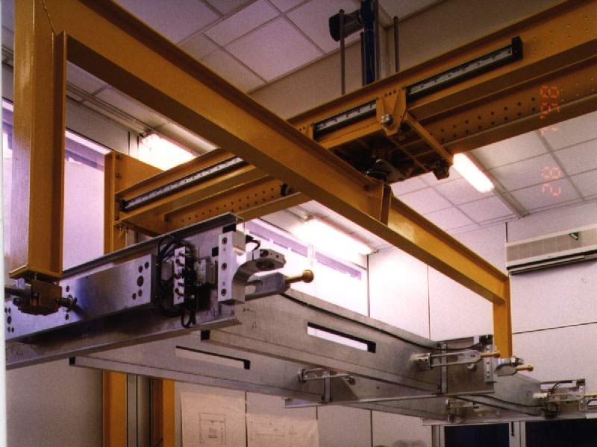
fork

End-block

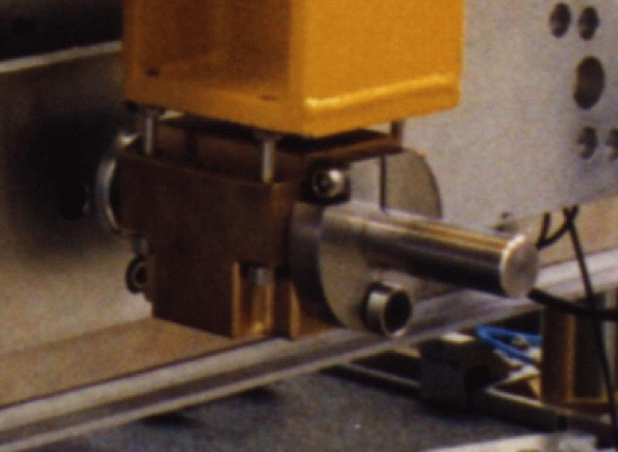
flange
screw A

